**CS610P Assignment #1 Spring 2024**

Name: Abdul Rehman

VU-ID: BC220424444

**Question:**

Consider a smart home setup, where a star topology network is employed. At the center of this network, there exists a powerful smart home hub, controlling all connected devices. Five different nodes (computers) represent various smart devices distributed throughout the home network. Mentioned below are the labeling of the topology design.

* **Central Hub**: Smart home controller in the living room (*should be labelled with your vuid*)
* **Node 1**: Smart thermostat in the hallway
* **Node 2**: Smart security camera system around the exterior
* **Node 3**: Smart refrigerator in the kitchen
* **Node 4**: Smart lighting system in the bedroom
* **Node 5**: Smart speaker system in the home office

This star topology network enables seamless communication between all devices and the central hub, facilitating efficient automation and control of the smart home environment. Each node is connected to the central hub; hence it can interact independently, enhancing convenience, comfort, and security for the residents.

In this scenario, you must ***design and structure*** the Star Topology with the proper *device configuration* using the Cisco Packet Tracer. You can configure each node in your smart home-based network with the following static IP addresses:

* **Central Hub**: Smart home controller in the living room (*should be labeled with your VUID*)
* **Node 1**: 192.168.1.3
* **Node 2**: 192.168.1.4
* **Node 3**: 192.168.1.6
* **Node 4**: 192.168.1.9
* **Node 5**: 192.168.1.11

**Solution:**

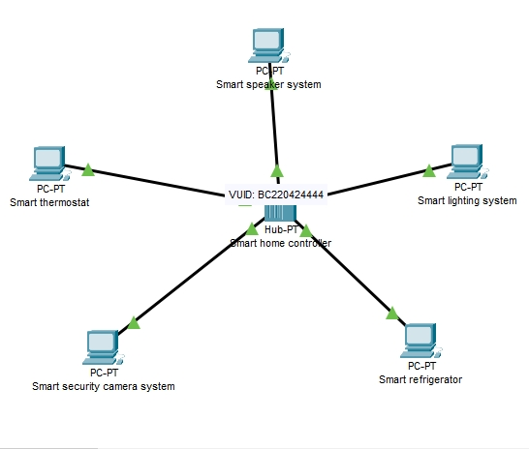

**Packet Tracer File:**

Here is Packet Tracer file, double click to open or copy and paste it anywhere and then open it.

